

**Department of Computer Applications**

Main Project Report

Organ Bank

#### Done by

**Dona Jince**

**Reg No:MAC23MCA-2024**

Under the guidance of

**Prof. Nisha Markose**

**2023-2025**

CERTIFICATE



**Organ Bank**

#### Certified that this is the bonafide record of project work done by

**Dona Jince**

**Reg No: MAC23MCA-2024**

#### during the third semester, in partial fulfilment of requirements for award of the degree

##### Master of Computer Applications

of

##### APJ Abdul Kalam Technological University Thiruvananthapuram

**Faculty Guide Head of the Department**

#### Prof. Nisha Markose Prof. Biju Skaria

**Project Coordinator Internal Examiners**

#### Prof. Sonia Abraham

**ACKNOWLEDGEMENT**

With heartfelt gratitude, I extend my deepest thanks to the almighty for his unwavering grace and blessings that have made this journey possible. May his guidance continue to illuminate my path in the years ahead.

I am immensely thankful to Prof. Biju Skaria, Head of the Department of Computer Applications, Prof. Sonia Abraham, our dedicated project coordinator and Prof Nisha Markose my main project guide, for their invaluable guidance and timely advice, which played a pivotal role in shaping this project. Their guidance, constant supervision, and provision of essential information were instrumental in the successful completion of the mini project.

I extend my profound thanks to all the professors in the department and the entire staff at MACE for their unwavering support and inspiration throughout my academic journey. My sincere appreciation goes to my beloved parents, whose guidance has been a beacon in every step of my path.

I am also grateful to my friends and individuals who generously shared their expertise and assistance, contributing significantly to the fulfillment of this endeavor.

**ABSTRACT**

The Organ Bank is a comprehensive digital solution designed to streamline and automate the process of organ donation, matching, and transplantation. Traditional organ donation systems rely heavily on manual processes, resulting in inefficiencies, delays, and missed life-saving opportunities. While some organizations maintain static websites for organ donor registration, these systems lack real-time functionality for managing donor-recipient data, organ matching, and hospital coordination. The Organ Bank addresses these limitations by providing an integrated platform that ensures reliability, transparency, and efficiency in organ transplantation management.

This project introduces a real-time, automated matching system that enhances the efficiency of organ allocation. The platform supports all key stakeholders, including administrators, donors, recipients, and hospitals, facilitating seamless coordination. Core features include automated organ matching based on medical compatibility, real-time notifications for transplant schedules and compatibility testing, and a feedback mechanism to ensure continuous improvement and accountability.

The system is built using Flutter for a responsive and intuitive user interface, ensuring seamless experiences across mobile and web platforms. The backend is powered by Node.js, which efficiently handles server-side logic and matching algorithms, while MongoDB provides secure, scalable, and real-time data storage and management. The development environment integrates Visual Studio Code, enabling smooth application development.

By utilizing these modern technologies, the Organ Bank enhances operational efficiency, reduces manual errors, and accelerates the decision-making process. Its real-time features and improved communication foster trust among stakeholders, ultimately increasing the success rate of organ transplants. This innovative approach not only optimizes the organ donation workflow but also contributes to the noble cause of saving lives, making it an essential tool in modern healthcare management.

* 1. Reference papers summary 5

### LIST OF FIGURES

* 1. Snapshot of WeatherAUS.csv 7
  2. Types of Attributes 8
  3. Count of each class labels 8
  4. Description of features 9
  5. Missing values in the dataset 9
  6. Dropped rows with RainTomorrow null 10
  7. Converting RainToday and RainTomorrow in to Numerical 10
  8. Filling missing values using Mode 10
  9. Converting categorical to numerical features 11
  10. Multiple Imputation using Chained Equations 11
  11. SMOTE 11
  12. Feature Importance using f_classif 12
  13. 10 Selected features 12
  14. Normalization using minmaxscalaer 12
  15. RainTomorrow distribution before smote 15
  16. RainTomorrow distribution after smote 15
  17. Missing value pattern 16
  18. Outlier detection 16
  19. Correlation between attributes 17
  20. Pairplot 18
  21. ANN model 19
  22. SVM working 20
  23. RF working 21
  24. ANN 22
  25. SVM 23
  26. RF 24
  27. Project pipeline 25
  28. Code snippet for dataset splitting 33
  29. Code snippet for ANN model training 33
  30. Code snippet for SVM model training 33
  31. Code snippet for RF model training 34
  32. ROC Curve 36
  33. Precision-Recall curve 36
  34. Code snippet for Rainfall Prediction 37
  35. Rainfall Prediction 37
  36. Home Page 39
  37. Index Page 39
  38. User input 40
  39. Alert while submitting the input 40
  40. Prediction 41
  41. Git history 42
  42. Git history of sprint 3 43

**CONTENTS**

**ACKNOWLEDGEMENT** i

**ABSTRACT** ii

**LIST OF TABLES** iii

**LIST OF FIGURES** iv

##### Introduction 1

##### Supporting Literature 2

* 1. Literature Review 2
     1. Summary Table 5
  2. Findings and Proposals 6

##### System Analysis 7

* 1. Analysis of Dataset 7
     1. About the Dataset 7
     2. Explore the dataset 8
  2. Data Pre-processing 10
     1. Data Cleaning 10
     2. Analysis of Feature Variables 13
     3. Analysis of Class Variables 14
  3. Data Visualization 15
  4. Analysis of Algorithms 19
     1. Activity Diagrams 22
  5. Project Plan 25
     1. Project Pipeline 25
  6. Feasibility Analysis 26
     1. Technical Feasibility 26
     2. Economic Feasibility 27
     3. Operational Feasibility 28
  7. System Environment 29
     1. Software Environment 29
     2. Hardware Environment 31

##### System Design 32

* 1. Model Building 32
     1. Model Planning 32
     2. Training 34
     3. Testing 34

1. Results and Discussion 35
2. Model Deployment 38
3. Git History 42
4. Conclusion 44
5. Future Work 45
6. Appendix 46
   1. Minimum Software Requirements 46
   2. Minimum Hardware Requirements 47
7. References 48
8. **INTRODUCTION**

The Organ Bank is a comprehensive digital solution developed as a mobile application to automate and streamline the process of organ donation, matching, and transplantation. This project eliminates the inefficiencies of traditional manual systems by providing an integrated, real-time platform that ensures reliability, transparency, and efficiency in managing organ donations and transplants.

The existing system for organ donation and transplantation often involves manual processes, leading to delays, inefficiencies, and missed opportunities for life-saving procedures. While some organizations maintain static websites for registration or informational purposes, these systems fail to provide dynamic solutions for managing donor and recipient data, organ matching, and hospital coordination. Such limitations result in underutilized resources, lack of transparency, and delayed decision-making, which can cost lives.

The Organ Bank addresses these shortcomings by introducing a dynamic and real-time platform designed to meet the needs of all stakeholders, including administrators, donors, recipients, and hospitals. Key features include automated organ matching based on medical criteria, real-time notifications for compatibility testing schedules, transplant dates, and a feedback mechanism to ensure continuous improvement and accountability.

The system uses Flutter for developing a responsive and intuitive user interface across both mobile and web platforms, ensuring seamless user experiences. Node.js powers the backend, efficiently handling server-side logic, organ matching algorithms, and business processes, while MongoDB serves as the database for secure, scalable, and real-time data storage and management. The development environment integrates Visual Studio Code for the mobile app.

By utilizing these modern technologies, the Organ Bank provides a robust and efficient solution that automates processes, reduces manual errors, and accelerates decision-making. Its real-time features and enhanced communication build trust among stakeholders while significantly improving the success rate of organ transplants. This innovative solution not only addresses critical challenges in organ donation and transplantation but also contributes significantly to the noble cause of saving lives, making it a vital tool for modern healthcare management.

**2. SUPPORTING LITERATURE**

**2.1 Literature Review**

Paper 1: Hawashin, D., Jayaraman, R., Salah, K., Yaqoob, I., Simsekler, M. C. E., & Ellahham, S. (2022). Blockchain-Based management for organ donation and transplantation. *IEEE Access*, *10*, 59013–59025. https://doi.org/10.1109/access.2022.3180008

The paper "Blockchain-Based Management for Organ Donation and Transplantation" by Diana Hawashin et al. explores the integration of blockchain technology to enhance organ donation and transplantation processes. Traditional organ donation systems face challenges such as inefficiencies, lack of transparency, and security risks due to manual processing and centralized data storage. The authors propose a private Ethereum blockchain-based system that ensures decentralization, security, traceability, and auditability in organ donation management. The use of smart contracts automates key processes, including donor-recipient matching, organ tracking, and real-time updates, ensuring a seamless and tamper-proof workflow.

The study introduces six key algorithms that automate various phases of organ transplantation, including donor registration, organ removal, transportation, and recipient matching. The blockchain-based system enables a ranked matching process that considers factors like blood type, BMI, and age compatibility, thereby ensuring fair and efficient organ allocation. Security analysis using the Oyente tool confirms that the smart contracts are resistant to vulnerabilities like transaction-ordering dependence and re-entrancy attacks. Additionally, a comparative study highlights blockchain’s advantages over conventional organ transplant management systems, emphasizing its potential to eliminate fraud, enhance real-time tracking, and improve trust among stakeholders.

The findings of this study align with the Organ Bank project, as both aim to optimize organ donation through technology. While your project is built using Flutter, Node.js, and MongoDB, integrating blockchain technology could further improve data security, transparency, and trust in organ matching and allocation. By adopting blockchain-based smart contracts, the system can prevent data manipulation, enhance organ traceability, and ensure real-time collaboration among hospitals, donors, and recipients. This research provides a strong foundation for future enhancements in your project, making it a more reliable, efficient, and scalable healthcare solution.

Paper 2: Dajim, L. A., Al-Farras, S. A., Al-Shahrani, B. S., Al-Zuraib, A. A., & Mathew, R. M. (2019). Organ Donation decentralized application using blockchain technology. *Organ Donation Decentralized Application Using Blockchain Technology*, 1–4. https://doi.org/10.1109/cais.2019.8769459

The paper "Organ Donation Decentralized Application Using Blockchain Technology" by Lama Abdulwahab Dajim et al. presents a blockchain-based approach to improving organ donation and transplantation systems. Traditional organ donation processes face challenges such as long waiting times, lack of transparency, and security vulnerabilities in centralized systems. The proposed decentralized web application ensures that donor and recipient information, including medical ID, blood type, and organ type, is securely recorded and managed. The system operates on a first-in, first-out basis, prioritizing critical cases when necessary, thus enhancing fairness and efficiency in organ allocation.

The study highlights the advantages of blockchain technology in maintaining data integrity, security, and transparency. By decentralizing organ donation records, the system eliminates risks associated with data manipulation and cyber threats. The authors discuss the use of smart contracts to automate key processes, such as donor registration, recipient matching, and organ tracking, ensuring real-time updates and preventing fraudulent activities. A comparative analysis of centralized, distributed, and decentralized systems underscores blockchain’s benefits, particularly in security, speed, scalability, and reliability.

This research is relevant to your Organ Bank project, as both systems aim to enhance organ donation management through technology. While your project is built using Flutter, Node.js, and MongoDB, integrating blockchain can further strengthen data security, improve transparency, and ensure real-time collaboration among donors, recipients, and hospitals. The study supports the idea that blockchain-based organ donation platforms can eliminate inefficiencies, enhance trust among stakeholders, and ultimately save more lives through a streamlined and secure process.

Paper 3: Somasundar, A., Chilakarao, M., Raju, B. R. K., Behera, S. K., Ramana, C. V., & Sethy, P. K. (2024). MongoDB integration with Python and Node.js, Express.js. *MongoDB Integration With Python and Node.js, Express.js*, 1–5. https://doi.org/10.1109/icaect60202.2024.10469546

The paper "MongoDB Integration with Python and Node.js, Express.js" by Santi Kumari Behera et al. presents a comprehensive study on integrating MongoDB, a widely used NoSQL database, with Python and Node.js. MongoDB’s scalability, flexibility, and document-centric structure make it an excellent choice for handling semi-structured and unstructured data in modern web applications. The authors examine the key drivers and APIs, particularly PyMongo for Python and Mongoose for Node.js, demonstrating their role in facilitating seamless database interactions. They also explore how MongoDB integrates with the MEAN stack (MongoDB, Express.js, Angular, and Node.js), a widely adopted web development framework.

A major focus of the study is indexing and query optimization in MongoDB, where techniques such as B-trees and hash tables are employed to improve query performance. The authors highlight the advantages of aggregation pipelines and MapReduce for efficient data processing, making MongoDB an ideal choice for big data analytics and real-time applications. Additionally, they address security vulnerabilities, such as unauthorized access and injection attacks, recommending best practices like authentication, encryption, and role-based access control to enhance database security.

This study is highly relevant to your Organ Bank project, as it validates the scalability, efficiency, and security of MongoDB for handling large volumes of donor-recipient data, real-time organ matching, and hospital coordination. The findings suggest that using Mongoose for Node.js and PyMongo for Python can streamline database interactions while ensuring data integrity and optimal query performance. By adopting the recommended security measures, your system can prevent unauthorized data manipulation and ensure reliable organ transplantation management.

**2.2 Literature Summary**

The paper "Blockchain-Based Management for Organ Donation and Transplantation" by Diana Hawashin et al. presents a solution to enhance the efficiency and security of organ donation systems. Traditional systems suffer from manual processes, data manipulation risks, and lack of real-time tracking. The study proposes a structured approach to donor-recipient matching, organ removal, transportation, and transplantation, aiming to ensure secure and transparent organ allocation. The authors highlight the importance of automating key steps in the organ donation process to minimize delays and improve trust between stakeholders.

Similarly, the study "Organ Donation Decentralized Application Using Blockchain Technology" by Lama Abdulwahab Dajim et al. supports the use of a digitized, automated platform for organ donation management. This research emphasizes the importance of data integrity, privacy, and transparency in organ transplantation. The proposed system ensures that patient records, organ availability, and recipient priority lists are managed efficiently and fairly. The study highlights that standardized organ allocation criteria and real-time communication between hospitals and medical teams play a crucial role in improving the organ donation process. Both studies advocate for automated donor-recipient matching systems to eliminate inefficiencies and enhance decision-making.

Efficient data management is crucial in organ donation systems, where large volumes of donor-recipient information require real-time access and updates. The paper "MongoDB Integration with Python and Node.js, Express.js" by Santi Kumari Behera et al. explores the advantages of using MongoDB, a widely adopted NoSQL database, for handling semi-structured and unstructured data in modern web applications. MongoDB’s scalability, flexibility, and document-oriented structure make it an ideal choice for organ donation platforms, where dynamic data storage and rapid retrieval are essential.

The study examines PyMongo for Python and Mongoose for Node.js, both of which facilitate seamless integration of MongoDB with web applications. The research also explores indexing mechanisms like B-trees and hash tables, which enhance query performance by reducing retrieval time. Security vulnerabilities such as injection attacks, unauthorized access, and data leakage are also analyzed, with recommended best practices including encryption, authentication, and role-based access control. These findings are highly relevant to organ donation systems, which require secure, efficient, and scalable data management solutions.

**2.3 Findings and Proposals**

The reviewed studies highlight the need for real-time updates and automated processes in organ donation management. A key proposal for the Organ Bank project is the implementation of real-time notifications for scheduling compatibility tests, transplant procedures, and result updates. This ensures that hospitals, donors, and recipients receive timely alerts, reducing delays in organ transplantation.

Another crucial recommendation is automated donor-recipient matching based on blood type and organ compatibility. Every time a donation or request is submitted, the system should instantly analyze the available donor-recipient data and provide the best possible matches. The use of MongoDB indexing and querying mechanisms will allow for fast and efficient retrieval of donor-recipient pairs, ensuring a seamless and automated matching process.

Furthermore, email communication should be integrated into the system to facilitate coordination among stakeholders. Whenever an organ match is found, the system should automatically send email notifications to the recipient, donor, and medical personnel involved, ensuring efficient communication and scheduling. These proposals align with modern digital automation trends and will significantly enhance the efficiency, security, and transparency of the Organ Bank system.

In conclusion, automated donor-recipient matching ensures efficient and fair organ allocation, while MongoDB integration provides scalability, high-speed data access, and security. These technologies can significantly improve data integrity, transparency, and real-time decision-making in organ donation management. By incorporating these advanced solutions, the Organ Bank project can establish a robust, automated, and life-saving platform for efficient organ donation and transplantation.

**3. SYSTEM ANALYSIS**

* 1. **. Module Description**
* **User Management**
* Donors, Recipients, and Hospitals can register themselves by providing necessary details such as personal information, contact details, and medical records (for donors and recipients).
* Hospitals provide their registration details, including location and address.
* Admin reviews the registration details.
* Approves or rejects registrations based on validity and authenticity of the provided information.
* Sends approval/rejection notifications to the respective users via mail.
* Donors and Recipients can update their profiles after approval.
* Hospitals can edit their details, such as contact information and services provided.
* **Donation Module**
* **Donors** can register and select the organ they wish to donate.
* Donors can update the availability status at any time before the match is approved by admin.
* Donors can view the status of the organ donated.
* **Request Module**
* **Receipients** can register and select the organ they wish to request.
* Receipients can view the status of the organ requested.
* **Organ Matching Module**
* Automatically matches registered donors and recipients based on compatibility factors such as blood group and organ type when a donation or request is submitted.
* Successful matches wait for admin approval.
* Admin approves the matches, and notifications are sent to the respective hospital.
* **Compatibility Testing Module**
* Hospitals schedule onsite compatibility tests for approved matches.
* Updates the system with test results (success /failure).
* Notifications are sent to the donor and receipient.
* **Transplantation Management Module**
* Hospitals conduct transplantation procedures after successful compatibility tests.
* Updates the system with transplantation outcomes (success or failure).
* Notifications are sent to Admin, Donors, and Recipients about the procedure status.
* **Feedback and Complaint Management Module**
  + Donors, Recipients, and Hospitals can submit feedback on their experiences, system usability, and hospital services.
  + Feedback is visible to the Admin for system improvement.
  + Donors and Recipients can raise complaints about hospital services, compatibility testing, or delays in processes.
  + Hospitals can report any issues related to the system or donor/recipient cooperation.
* **Report Management Module**

Admin generates reports on:

* + Registered Donors, Recipients, and Hospitals.
  + Organ availability (filtered by type and donor status).
  + Transplantation outcomes and success rates.

**3.2 Feasibility Analysis**

**3.2.1 Technical Feasibility**

The Organ Bank system is technically feasible due to the use of a robust and widely adopted technology stack that ensures efficiency, scalability, and seamless integration. The frontend is built using Flutter, a cross-platform framework that allows the application to run smoothly on Android, iOS, and web platforms. Dart, the programming language used in Flutter, provides high-performance animations, a responsive UI, and efficient application execution, ensuring an intuitive and seamless user experience for donors, recipients, hospitals, and administrators.

The backend is powered by Node.js, a fast, scalable, and event-driven environment that efficiently handles server-side logic, donor-recipient matching algorithms, notifications, and authentication. The system employs RESTful APIs to ensure seamless communication between the frontend and the database, allowing real-time data exchange and updates. A key technical feature of the Organ Bank is its real-time scheduling system, which provides instant updates on compatibility tests, transplant scheduling, and result notifications, ensuring timely coordination among all stakeholders.

The database is managed using MongoDB, a highly scalable and flexible NoSQL database that efficiently handles semi-structured and unstructured data such as donor-recipient profiles, organ availability, and transaction logs. MongoDB's schema-less design allows for easy scalability and modification of records as new data is added. Indexing and querying mechanisms further enhance performance by enabling fast and efficient retrieval of donor-recipient matches. Every time a donation or request is submitted, the system automatically updates the matching records, ensuring an accurate and reliable process.

Additionally, the system incorporates email-based communication to keep stakeholders informed about critical updates. When a compatible donor-recipient match is found, an automated email notification is sent to relevant parties, including hospitals, doctors, and patients, ensuring prompt coordination and decision-making. The combination of Flutter, Node.js, and MongoDB provides a modern, efficient, and scalable solution that ensures reliability, security, and accessibility, making the Organ Bank a technically feasible system that can be successfully implemented and deployed.

**3.2.2 Economical Feasibility**

The Organ Bank project is economically feasible as it utilizes cost-effective open-source technologies, significantly reducing development and operational costs. The system is built using Flutter for frontend development, Node.js for backend logic, and MongoDB for database management, all of which are open-source frameworks that eliminate the need for expensive software licenses. This approach reduces initial setup costs and provides a financially viable solution for hospitals and organizations looking to implement a modern organ donation system.

The availability of skilled developers further enhances the project's economic feasibility. Flutter, Node.js, and MongoDB are widely adopted technologies, making it easy to find experienced developers at competitive rates. This lowers hiring costs and allows for faster development and deployment, reducing the overall financial burden of building and maintaining the system. Additionally, the use of cloud-based hosting solutions minimizes infrastructure costs while ensuring scalability and accessibility.

Another key factor contributing to the system’s cost-effectiveness is automation. The automated organ-matching algorithm eliminates the need for manual data processing, reducing the workload of hospital staff and minimizing administrative expenses. The system also includes automated real-time scheduling for compatibility testing, transplant coordination, and result notifications, ensuring that resources are used optimally. This efficiency translates into reduced labor costs, making the system an economically sound investment.

Although initial development, deployment, and maintenance costs are involved, the long-term benefits of the Organ Bank system justify the investment. By optimizing workflows, reducing errors, and improving decision-making, the system leads to cost savings in the healthcare sector. The automation of critical processes also increases the number of successful transplants, ultimately making the system a financially sustainable solution that improves efficiency, resource utilization, and patient outcomes.

**3.2.3 Operational Feasibility**

The Organ Bank system is highly feasible from an operational standpoint, as it streamlines the organ donation and transplantation process while enhancing efficiency, transparency, and trust among all stakeholders. The system’s Flutter-based frontend ensures a seamless, user-friendly experience for donors, recipients, hospitals, and administrators, making it accessible across multiple platforms. The intuitive UI enables users to register, track organ availability, and receive real-time updates with minimal effort, ensuring smooth operations.

The backend, powered by Node.js and MongoDB, efficiently manages user authentication, organ matching, and transaction logs, ensuring real-time data access and high system availability. One of the most crucial operational components is the automated donor-recipient matching system, which eliminates delays in organ allocation. Whenever a new donation or request is submitted, the system instantly analyzes donor and recipient profiles, using blood type and organ compatibility as key matching criteria. This automation significantly improves matching accuracy and speed, increasing the likelihood of successful transplants.

Another vital feature is real-time scheduling and updates. The system automates the compatibility testing process, notifying relevant stakeholders about test schedules, transplant procedures, and final results. These updates are delivered via automated email notifications, ensuring that all involved parties—including hospitals, doctors, and patients—are informed in a timely manner. The use of email-based communication enhances operational coordination, reducing miscommunication and delays.

The Organ Bank system also enhances trust and transparency through its notification and feedback mechanisms. By keeping users informed at every stage of the process, the system ensures that donors, recipients, and medical staff remain engaged and aware of critical updates. Additionally, the automation of data logging and tracking minimizes human error and ensures compliance with medical regulations. The system’s ability to optimize workflows, minimize manual interventions, and improve coordination makes it an operationally viable solution that can be effectively implemented in real-world healthcare settings. With continuous updates, dedicated technical support, and strong security measures, the Organ Bank system is positioned for long-term success and scalability.

**3.2.2 Analysis of Features**

Analysis of features describe their relevance to rainfall prediction and potential influence on the machine learning model:1. Date: Represents the day the measurements were recorded. Although not directly useful for prediction, it may be helpful for identifying seasonal patterns in rainfall.2. Location: Indicates the weather station's location, which is valuable for capturing regional climate variations that affect rainfall. Different locations may have unique weather trends.3. MinTemp: The minimum temperature recorded during the day. Lower temperatures might correlate with rainfall as temperature affects atmospheric conditions.4. MaxTemp: The maximum temperature recorded during the day. High temperatures can influence evaporation rates and humidity, impacting the likelihood of rainfall.5. Rainfall: Records the amount of rainfall (in mm) for the day, providing context for past rainfall, which can be a predictor for future rainfall events.6. Evaporation: Reflects the amount of water evaporated (in mm) over 24 hours. Higher evaporation rates may indicate drier conditions, which could be inversely related to rainfall probability.7. Sunshine: Measures the hours of sunlight received during the day. Less sunshine often correlates with cloudy or rainy conditions, making this feature relevant for rainfall prediction.8. WindGustDir: The direction of the strongest wind gust over 24 hours. Specific wind directions can signal approaching weather systems that may bring rain.9. WindGustSpeed: The speed of the strongest wind gust (km/h). Strong wind gusts can signify stormy weather conditions, potentially leading to rainfall.10. WindDir9am: The direction of the wind at 9 a.m., which may indicate early atmospheric conditions relevant for rainfall prediction.11. WindDir3pm: The wind direction at 3 p.m., helping to capture weather changes throughout the day that might influence evening or overnight rain.12. WindSpeed9am: The average wind speed before 9 a.m., which can affect evaporation rates and indicate changing weather conditions.13. WindSpeed3pm: The average wind speed before 3 p.m., similar to WindSpeed9am, providing additional insight into atmospheric conditions as they develop.14. Humidity9am: The humidity percentage at 9 a.m. High humidity often indicates moisture in the air, which could increase the likelihood of rainfall.15. Humidity3pm: The humidity percentage at 3 p.m. This feature is critical for short-term rainfall prediction as high afternoon humidity might signal impending rain.16. Pressure9am: The atmospheric pressure at 9 a.m. Low pressure often correlates with rainy weather, so this feature is a valuable predictor.17. Pressure3pm: Atmospheric pressure at 3 p.m., allowing the model to track pressure changes throughout the day to detect potential rain events.18. Cloud9am: Fraction of the sky covered by clouds at 9 a.m. (measured in oktas). Higher cloud cover suggests overcast conditions, which can indicate rain.19. Cloud3pm: Fraction of the sky covered by clouds at 3 p.m. This provides an afternoon snapshot of cloudiness, useful for predicting rain later in the day.20. Temp9am: The temperature at 9 a.m., helpful for understanding morning atmospheric conditions.21. Temp3pm: The temperature at 3 p.m., capturing afternoon conditions that may affect the likelihood of rainfall later in the day.22. RainToday: A boolean indicator of whether rain was recorded today (1 for yes, 0 for no). This is directly relevant, as recent rainfall may suggest weather patterns likely to bring more rain.Each feature contributes uniquely to understanding atmospheric conditions and has the potential to influence rainfall prediction models. The diversity and completeness of these meteorological parameters make the dataset highly suitable for machine learning applications focused on predicting rainfall.

**3.2.3 Analysis of Class Variables**

The class variable in the "WeatherAUS" dataset is RainTomorrow, which is a binary variable indicating whether it rained the following day. This variable has two possible values:

1: Indicates that rainfall was recorded the next day (Yes).

0: Indicates that no rainfall was recorded the next day (No).

**3.3 Data Visualization**

Data visualization serves as a fundamental technique in data analysis, offering a graphical representation of information through charts, graphs, and maps. Its significance lies in transforming complex datasets into visually intuitive formats, allowing for the identification of trends, patterns, and outliers. This visual representation enhances data exploration, enabling easy comparison between data points and facilitating effective communication of insights. The diverse types of visualizations, such as charts for trends, tables for structured data, graphs for relationships, maps for geographic data, and dashboards for comprehensive displays, cater to various analytical needs. Utilizing tools like Tableau, Excel, or programming libraries like Matplotlib, data visualization aids in making data- driven decisions by providing accessible insights into massive amounts of information.

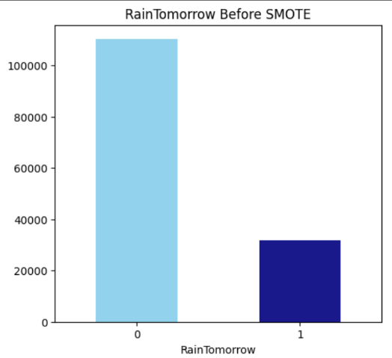

**Figure 3.15** RainTomorrow distribution before smote

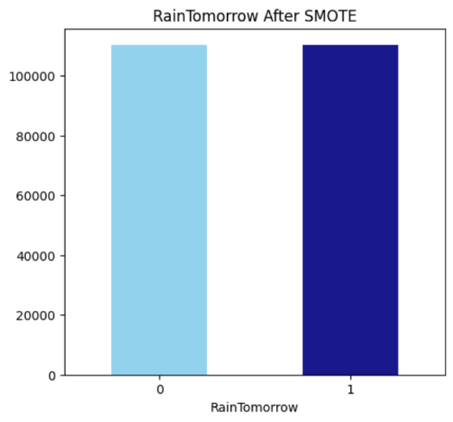

**Figure 3.16** RainTomorrow distribution after smote

Figure 3.15 and 3.16 shows the distribution of target variable RainTomorrow before and after smote.

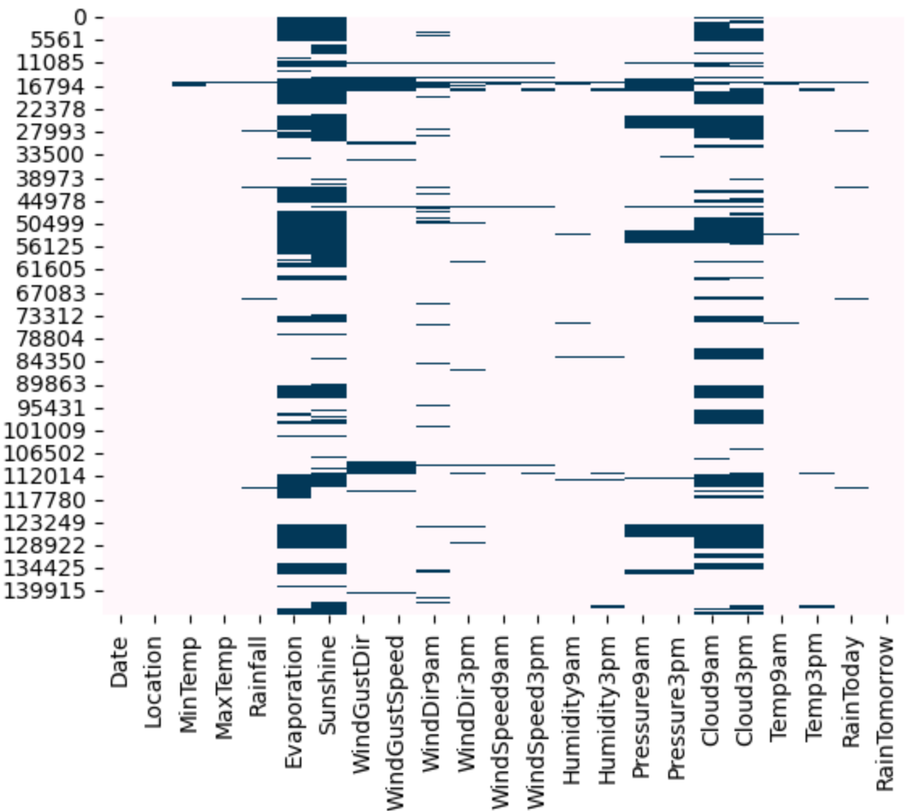

**Figure 3.17** Missing value pattern

Figure 3.17 shows the missing value pattern in the dataset before data cleaning.

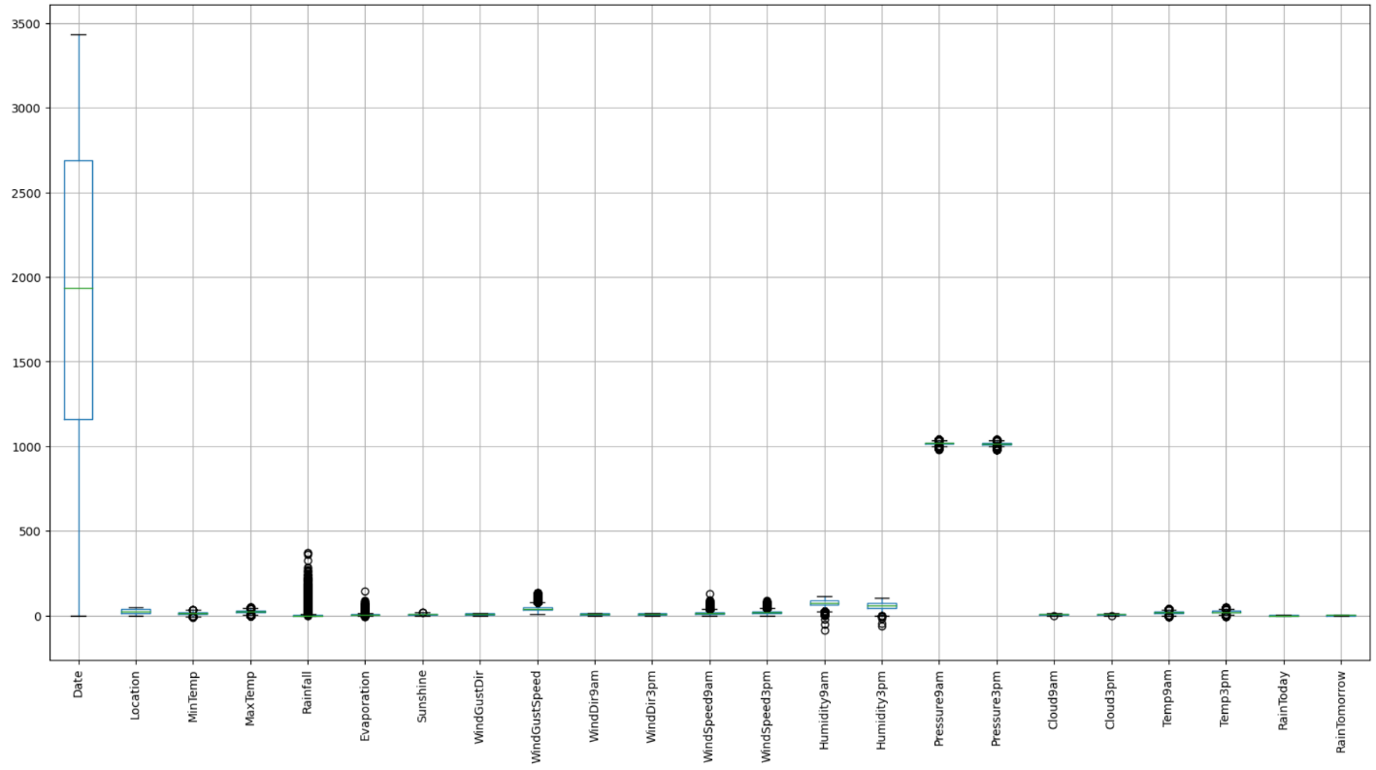

**Figure 3.18** Outlier Detection

Figure 3.18 shows that there are no outliers in the dataset.

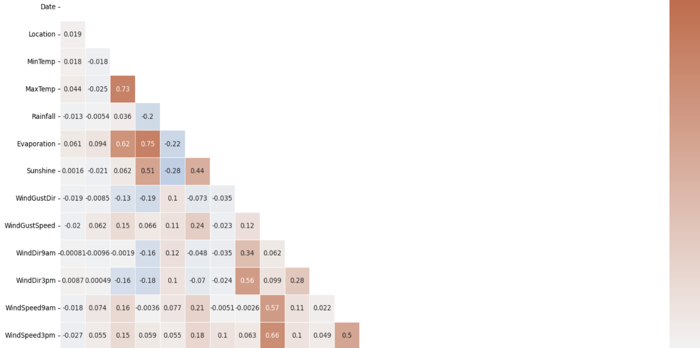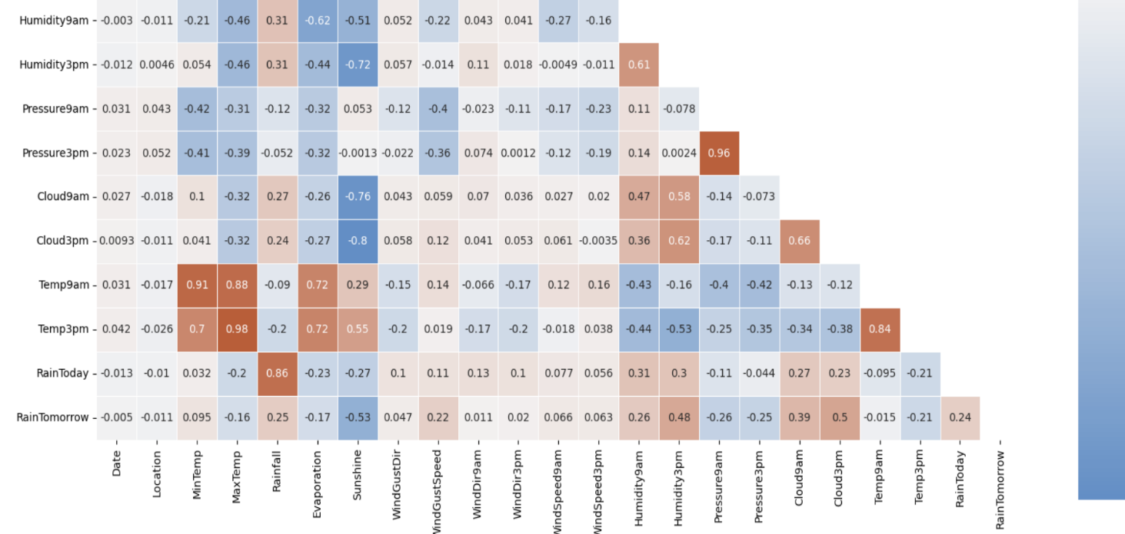

**Figure 3.19** Correlation between attributes

Figure 3.19 shows the correlation between attributes.The following feature pairs have a strong

correlation

with each other:

* MaxTemp and Temp3pm
* Pressure3pm and Pressure9am
* Temp9am and MinTemp
* Temp9am and MaxTemp

But in no case is the correlation value equal to a perfect “1”. We are therefore not removing any functionality

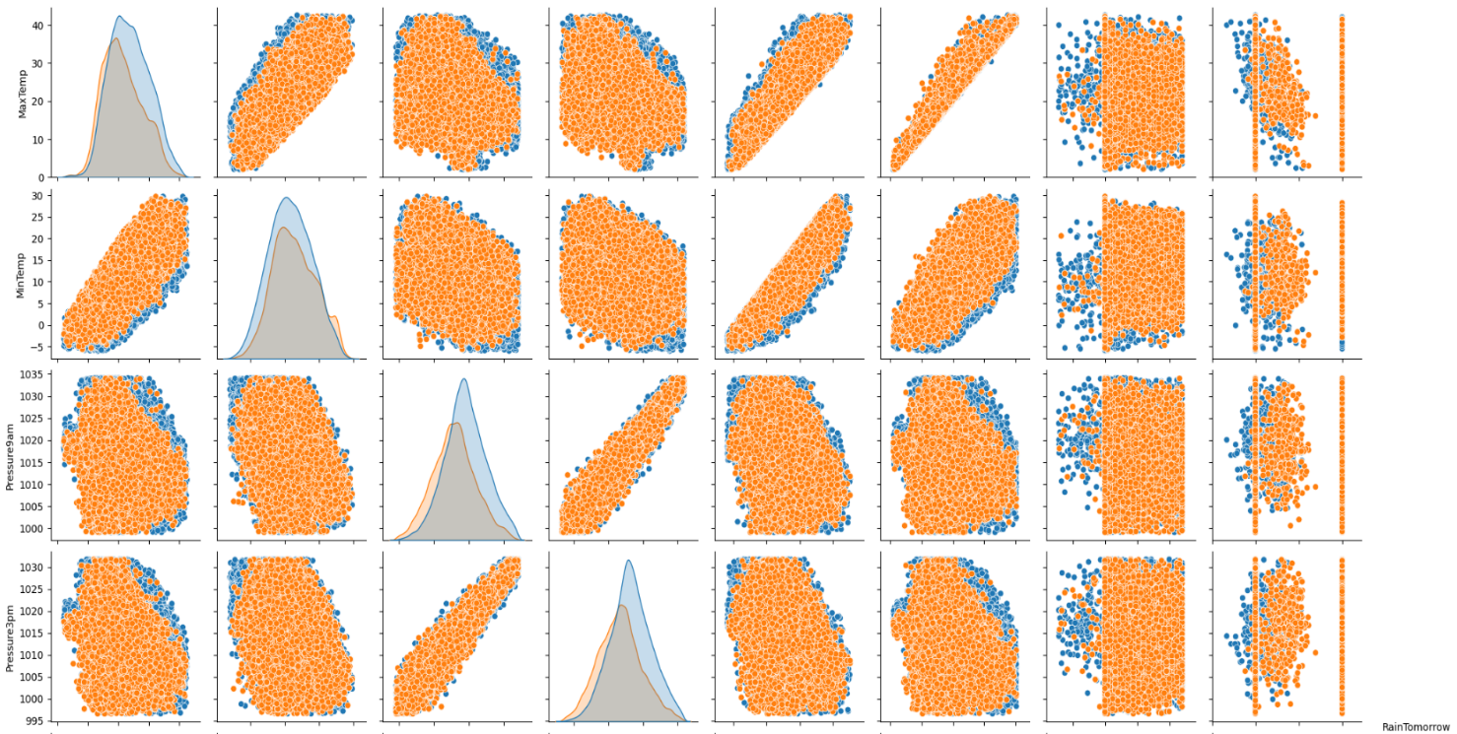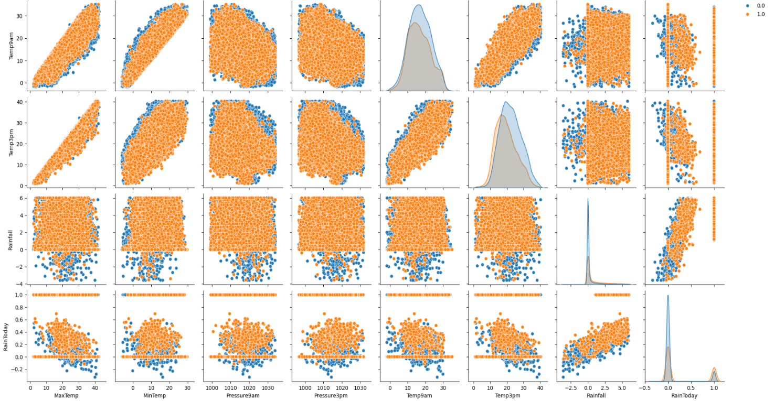

**Figure 3.20** Pairplot

Figure 3.20 shows a pairplot .Each of the paired plots shows very clear distinct clusters of

RainTomorrow’s “yes” and “no” clusters. There is very minimal overlap between them.

**3.4 Analysis of Algorithms**

Algorithms used in Rainfall Prediction Using Machine Learning are Artificial Neural Networks,Support Vector Machines and Random Forest.

### ****Artificial Neural Networks (ANN)****

#### **Artificial Neural Networks (ANNs) are highly flexible machine learning models designed to capture complex and nonlinear relationships in data, making them particularly well-suited for rainfall prediction tasks. In this project, ANN will be used to model intricate dependencies between meteorological variables such as temperature, humidity, wind speed, and atmospheric pressure, which collectively influence rainfall patterns. ANNs work by passing input features through multiple layers of interconnected nodes (neurons), each of which performs a weighted sum of inputs and applies an activation function to introduce nonlinearity. By training the ANN on the "WeatherAUS" dataset, the model learns subtle patterns in weather conditions that indicate whether it will rain the following day ("RainTomorrow"). Through backpropagation, the network adjusts weights iteratively to minimize prediction error, improving accuracy over time. ANNs are known for their robustness against noise and ability to generalize well to new data, making them ideal for capturing the variable nature of weather. The model’s ability to learn from historical data and adapt to new patterns positions it as a promising approach for accurate rainfall prediction.**

#### **Pseudocode:**

Initialize weights and biases

For each epoch:

For each input sample:

Perform forward propagation through all layers

Calculate the loss

Perform backpropagation to update weights and biases

End For

End For

Use the trained model to make predictions

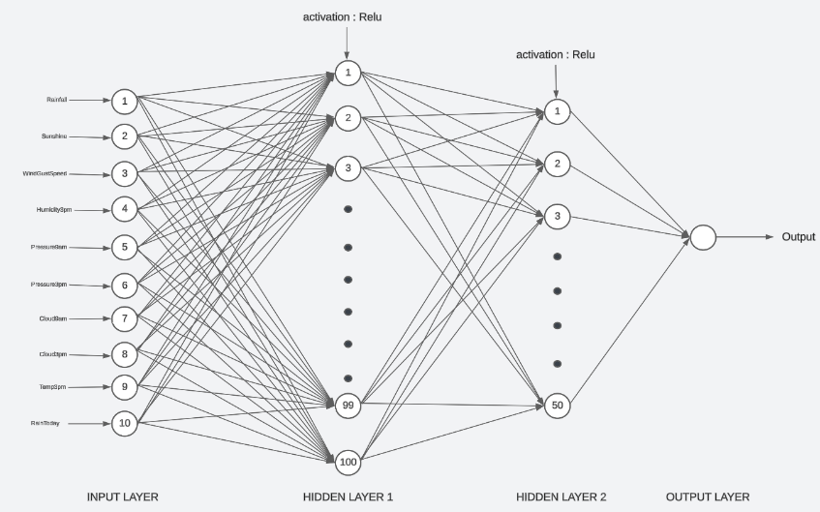

**Figure 3.21** ANN model

Figure 3.21 shows an ANN model.

### ****Support Vector Machines****

Support Vector Machine (SVM) is a powerful classification algorithm designed to find the optimal hyperplane that best separates data points into distinct classes. In the context of this project, SVM will be applied to classify days into two classes based on whether it will rain the following day ("RainTomorrow" - yes or no), using a set of meteorological features such as temperature, humidity, and wind speed. SVM is particularly useful for datasets with high dimensionality and can handle both linear and nonlinear relationships by using kernel functions (e.g., radial basis function, polynomial). For rainfall prediction, SVM’s strength lies in its ability to create a clear separation between classes by maximizing the margin, ensuring robust and reliable predictions. Additionally, SVM’s effectiveness in minimizing overfitting, especially with noisy or limited data, makes it suitable for dealing with real-world meteorological datasets. By leveraging the power of SVM, this project aims to develop a model that accurately classifies weather data into rain and no-rain categories, offering reliable predictive capabilities for practical applications like agriculture and disaster management.

#### **Pseudocode:**

Transform the input data using a kernel function (if needed)

Find the optimal hyperplane that maximizes the margin

Identify support vectors

For each new input sample:

Calculate the decision function based on the hyperplane

Assign the sample to a class based on the sign of the decision function

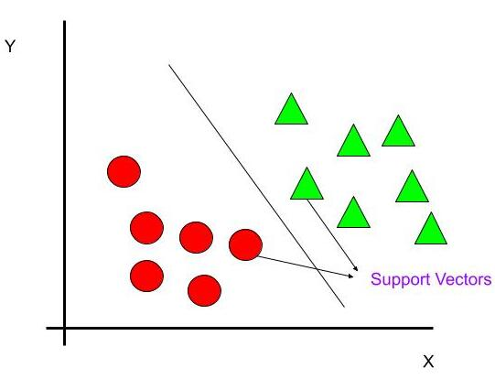

**Figure 3.22** SVM working

Figure 3.22 shows how SVM classifies the data samples. In the above figure there are two

classes,separated by a hyperline.

**Random Forest**

Random Forest (RF) is an ensemble learning method that constructs multiple decision trees and combines their outputs to make more stable and accurate predictions. In this project, Random Forest will be used to analyze weather features such as historical rainfall, wind speed, humidity, and atmospheric pressure to determine whether it will rain the following day. Each tree in the forest learns from a random subset of features, which helps to reduce overfitting and increase robustness against noisy or irrelevant data.. Random Forest is especially valuable in this project for its ability to calculate feature importance, allowing us to identify which meteorological parameters most influence the likelihood of rain. This interpretability makes RF a useful model not only for prediction but also for understanding the underlying factors driving rainfall patterns. By leveraging RF’s strengths in handling large feature spaces, handling non-linear relationships, and providing reliable performance, the project aims to build a robust and interpretable rainfall prediction model that can aid in decision-making across various fields, including agriculture, water resource management, and weather forecasting.

#### **Pseudocode:**

For each tree in the Random Forest:

Bootstrap sample the data

Randomly select a subset of features for each split

Build the decision tree using the selected features and bootstrap sample

Repeat until the maximum depth or minimum sample size is reached

End For

For each new input sample

Pass the sample through each decision tree in the forest

Record the output (class or regression value) from each tree

Aggregate the outputs:

- For classification: Use majority voting to determine the final class label

- For regression: Compute the average of the outputs to get the final prediction

Return the aggregated result as the final prediction

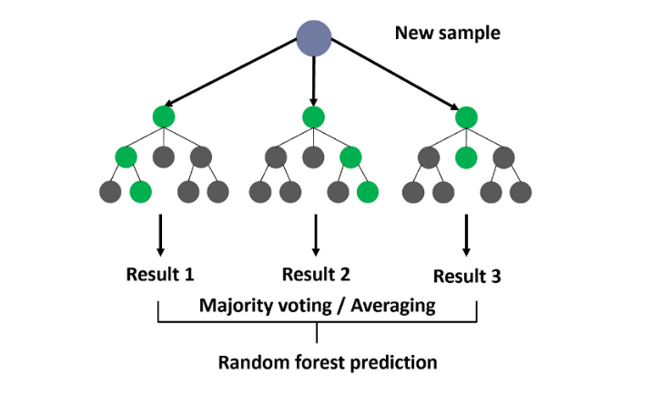

**Figure 3.23** RF working

Figure 3.23 shows how RF works.

**3.4.1 Activity Diagrams**

**Data Collection**

**Data Preprocessing**

Handle Missing Values Normalize Features

Feature Selection

**Split Dataset**

Training Set (80%)

Testing Set (20%)

**Train ANN Model**

Initialize Weights

Forward Pass

Backpropagation

Optimize Weights

**Evaluate ANN Model**

Accuracy, Precision, Recall, F1 Score

**Predict Rainfall**

(yes/no)

**Figure 3.24** ANN

Fig 3.24 shows the activity diagram of ANN model

**Data Collection**

**Data Preprocessing**

Handle Missing Values Normalize Features

Feature Selection

**Split Dataset**

Training Set (80%)

Testing Set (20%)

**Train SVM Model**

Select Kernel

Set Hyper-parameters

**Evaluate SVM Model**

Accuracy, Precision, Recall, F1 Score

**Predict Rainfall**

(yes/no)

**Figure 3.25** SVM

Fig 3.25 shows the activity diagram of SVM model

**Data Collection**

**Data Preprocessing**

Handle Missing Values Normalize Features

Feature Selection

**Split Dataset**

Training Set (80%)

Testing Set (20%)

**Train RF Model**

Create Trees

Bootstrap Aggregation

Ensemble of Models

**Evaluate RF Model**

Accuracy, Precision, Recall, F1 Score

**Predict Rainfall**

(yes/no)

**Figure 3.26** RF

Fig 3.26 shows the activity diagram of RF model

**3.5 Project Plan**

**3.5.1 Project Pipeline**

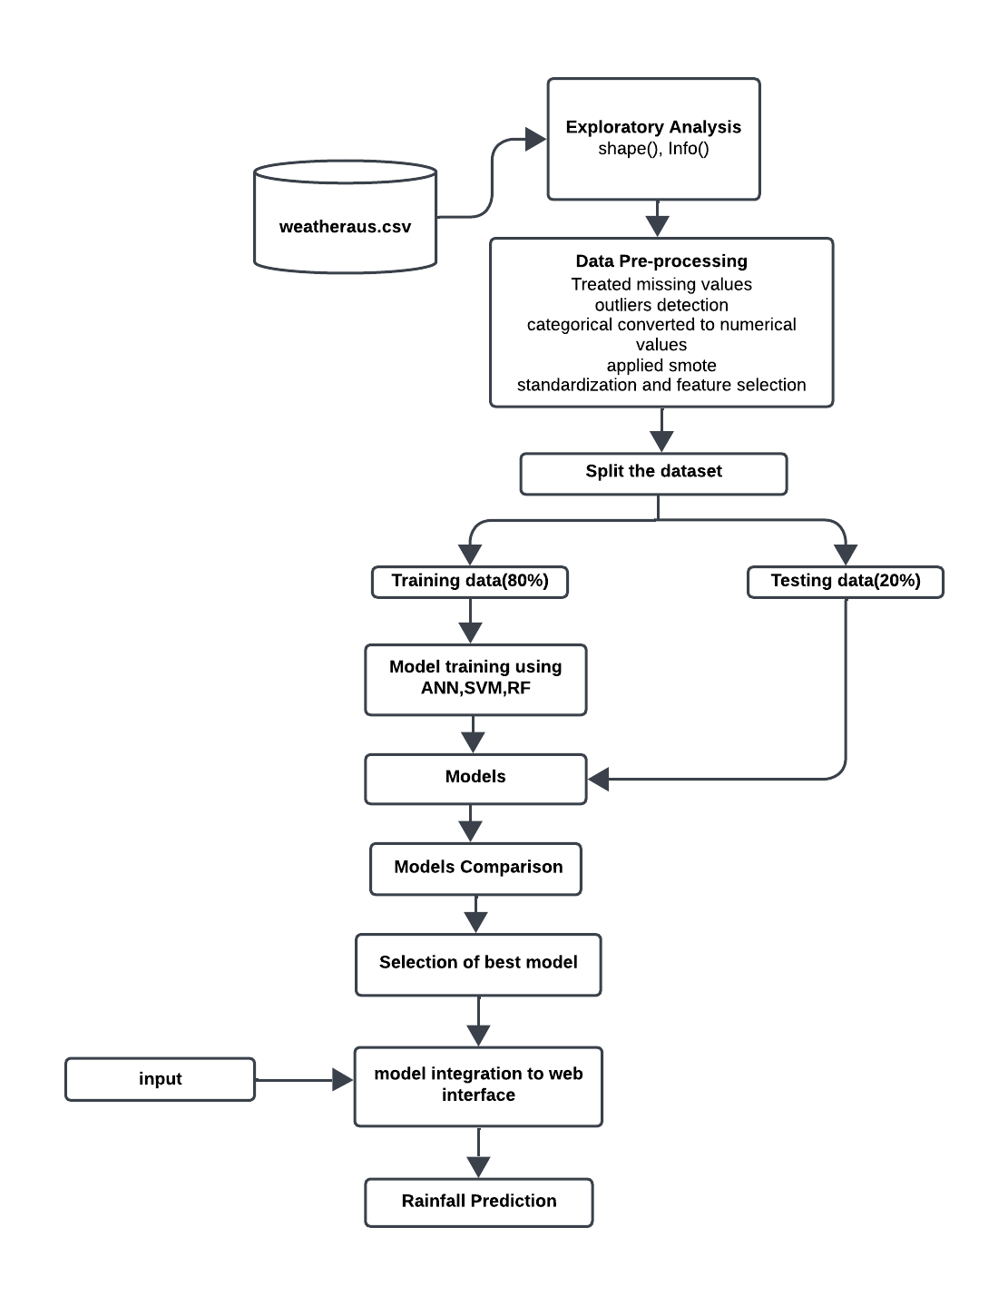

**Figure 3.27** Project Pipeline

Figure 3.27 shows the project pipeline.

**3.6 Feasibility Analysis**

A feasibility study aims to objectively and rationally uncover the strengths and weaknesses of an existing system or proposed system, opportunities and threats present in the natural environment, the resources required to carry through, and ultimately the prospects for success.

Evaluated the feasibility of the system in terms of the following categories:

* Technical Feasibility
* Economic Feasibility
* Operational Feasibility

**3.6.1 Technical Feasibility**

Technical feasibility assesses whether the technology required for the project is readily available and if the team has the expertise to implement it effectively.

1. **Data Processing and Analysis**

* **Feasibility**: The project relies on standard data processing libraries like NumPy, Pandas, and scikit-learn for handling and analyzing weather data. These libraries are well-supported, widely used in data science projects, and suitable for handling the large datasets involved, ensuring technical feasibility.
* **Expertise**: Familiarity with these tools, as demonstrated by their use in previous projects, indicates that the team possesses the technical competency to handle data preprocessing, cleaning, and analysis effectively.

1. **Machine Learning Algorithms**

* **Feasibility**: The project employs Artificial Neural Networks (ANN), Support Vector Machines (SVM), and Random Forest (RF) for rainfall prediction. These algorithms are widely used and have proven effective in predictive modeling tasks, particularly in weather prediction scenarios, ensuring their feasibility for this project.
* **Expertise**: The successful implementation of these algorithms demonstrates the team's understanding of machine learning concepts and their proficiency in applying these methods to real-world datasets.

1. **Data Visualization**

* **Feasibility**: Visualization libraries such as Matplotlib and Seaborn are used to display data trends, making it easy to explore patterns in the weather data. Both are open-source and technically feasible for data visualization tasks.
* **Expertise**: The team's capability to use these tools effectively for data visualization suggests proficiency, enhancing the project's technical viability.

1. **File Handling**

* **Feasibility**: Using Pandas for reading and writing CSV files is a standard practice in data handling, ensuring technical feasibility for managing dataset inputs and outputs.
* **Expertise**: Proficiency in file handling and data manipulation demonstrates the team’s competence, which is essential for efficiently managing the dataset throughout the project.

**3.6.2 Economic Feasibility**

Economic feasibility evaluates whether the project is financially viable, considering costs and potential benefits.

1. **Development Costs**

* **Feasibility**: By utilizing open-source tools and libraries, the project minimizes software acquisition costs. However, potential expenses may include personnel, training, and necessary hardware upgrades if needed for efficient model training.
* **Benefits**: An accurate rainfall prediction system could provide significant value in areas such as agriculture, disaster management, and environmental monitoring, justifying the development costs.

1. **Maintenance Costs**

* **Feasibility**: Since the project uses open-source libraries, maintenance costs are low, with occasional costs associated with updating models, refining algorithms, or addressing data drift.
* **Benefits**: The long-term benefits, such as accurate predictions that support agricultural planning or disaster preparedness, could justify the modest maintenance expenses involved.

1. **Potential ROI**

* The project can provide an ROI by offering a practical solution for rainfall prediction, potentially attracting partnerships or funding from agricultural, environmental, or governmental sectors that could benefit from accurate weather forecasting.

**3.6.3 Operational Feasibility**

Operational feasibility examines how well the project aligns with operational requirements and its potential for seamless integration into existing workflows.

1. **User Acceptance**

* **Feasibility**: The project aims to provide rainfall predictions that are easy for end-users (e.g., farmers, environmentalists) to understand and apply, increasing its likelihood of user acceptance.
* **Integration**: The web interface, built using Flask, is designed for accessibility and ease of use, making it suitable for users with minimal technical knowledge, thereby enhancing operational feasibility.

1. **Scalability**

* **Feasibility**: The project should consider scalability to accommodate a larger user base and potential expansion to include weather data from multiple regions. As the data volume and user base grow, the models and data infrastructure may need to be optimized.
* **Mitigation**: Implementing optimizations like feature selection or deploying models on a cloud infrastructure could help maintain efficiency as the project scales.

1. **Ease of Use**

* **Feasibility**: A user-friendly web interface will ensure ease of access for non-technical users, enhancing the operational feasibility of the project.
* **Training**: With intuitive design and straightforward data input fields, users should find the system easy to navigate, with minimal training requirements. This focus on usability will further improve operational adoption.

**3.7 System Environment**

**3.7.1 Software Environment**

The software environment encompasses the tools, frameworks, and platforms utilized in the development and execution of the forcating system.

Programming Languages:

**Python**: The primary programming language employed for its versatility, extensive libraries (NumPy, Pandas, scikit-learn), and strong support in data science and machine learning.

**Data Processing and Analysis**:

NumPy and Pandas: Utilized for efficient data manipulation, handling, and analysis.

**Machine Learning Libraries**:

scikit-learn: Used for implementing and training machine learning models, including Artificial Neural Networks, Support Vector Machines and Random Forest.

SciPy: Complements NumPy and provides additional functionality for scientific computing.

**Data Visualization**:

Matplotlib and Seaborn: Chosen for creating insightful visualizations, aiding in the exploration and communication of data patterns.

**File Handling:**

Pandas: Applied for reading and writing data to CSV files, ensuring seamless data management.

**Development Environment**:

Google Colab

Colab is a free Jupyter notebook environment that runs entirely in the cloud. We can write and execute code in Python. Colab supports many machine learning libraries which can be easily loaded in the colab notebook. Visual Studio Code is a streamlined code editor with support for development operations like debugging, task running, and version control. It aims to provide just the tool a developer needs for a quick code-build-debug cycle and leaves more complex work flows to fuller featured IDEs, such as [Visual Studio IDE](https://visualstudio.microsoft.com/).

HTML and CSS

Hyper Text Markup Language is used for creating web pages.HTML describes the structure of the web page. Here, the user interface of my project is done using HTML. Cascading Style Sheet is used with HTML to style the web pages.

Flask

Flask is a web framework, it’s a Python module that lets you develop web applications easily. It’s has a small and easy-to-extend core: it’s a microframework that doesn’t include an ORM (Object Relational Manager) or such features. It does have many cool features like URL routing, template engine. It is a WSGI web app framework.

GitHub

Git is an open-source version control system that was started by Linus Torvalds. Git is similar to other version control systems Subversion, CVS, and Mercurial to name a few. Version control systems keep these revisions straight, storing the modifications in a central repository. This allows developers to easily collaborate, as they can download a new version of the software, make changes, and upload the newest revision. Every developer can see these new changes, download them, and contribute. Git is the preferred version control system of most developers, since it has multiple advantages over the other systems available. It stores file changes more efficiently and ensures file integrity better.

The social networking aspect of GitHub is probably its most powerful feature, allowing projects to grow more than just about any of the other features offered. Project revisions can be discussed publicly, so a mass of experts can contribute knowledge and collaborate to advance a project forward.

**3.7.2 Hardware Environment**

The hardware environment refers to the physical infrastructure necessary to support the development and deployment of the recommendation system.

**Computing Resources**:

Processor: 2 GHz, A powerful multi-core processor is recommended to handle the computational demands efficiently. Consider a processor with at least quad- core architecture for optimal performance.

**Storage**:

Sufficient Disk Space: 512 GB SSD Memory (RAM):

8 GB RAM: Sufficient RAM is crucial for efficiently handling large datasets and performing machine learning tasks.

**Internet Connectivity**:

High-Speed Internet: A stable and high-speed internet connection is essential for accessing online resources, libraries, and datasets during development.

**4. SYSTEM DESIGN**

**4.1 Model Building**

### 4.1.1 Model Planning

The primary aim of the model planning phase in the rainfall prediction project is to create a structured roadmap for building an accurate predictive model. This phase involves defining clear objectives, selecting appropriate algorithms, and outlining strategies to process and analyze the WeatherAUS dataset effectively for rainfall prediction.

**1.** **Objective**

Develop a rainfall prediction model using Machine Learning algorithms that can accurately predict the likelihood of rainfall on the following day, based on various meteorological parameters provided in the WeatherAUS dataset.

**2.** **Approach**

Utilize Artificial Neural Networks (ANN), Support Vector Machines (SVM), and Random

Forest (RF) as the core algorithms for predictive modeling. Each algorithm will provide unique insights:

* ANN: A neural network model to capture complex non-linear relationships in the data.
* SVM: A classification model to find the optimal hyperplane, effectively distinguishing

between rainy and non-rainy days.

* RF: An ensemble-based model that aggregates multiple decision trees for robust, accurate predictions.

**3.** **Data Preparation**

Import and preprocess the WeatherAUS dataset. This includes handling missing values,

encoding categorical variables, and scaling numerical features as needed to ensure that

the dataset is clean and suitable for model training.

**4.** **Exploratory Data Analysis (EDA)**

Conduct a thorough analysis of the dataset to identify patterns and relationships between features. Key areas of focus include distribution of rainfall across different locations, identifying correlations between meteorological features, and examining trends over time. Visualizations will aid in understanding these relationships and refining the feature set.

**5.Algorithm Implementation**

Implement each of the chosen algorithms (ANN, SVM, RF) using scikit-learn and TensorFlow/Keras. The models will be trained on the preprocessed dataset, and hyperparameter tuning will be performed to optimize their performance for accurate rainfall prediction.

**6.** **Evaluation and Comparison**

Evaluate each model's performance using metrics such as accuracy, precision, recall, and F1-score. The models will be compared based on these metrics, and the best-performing model will be selected for final deployment.

This structured plan will ensure a methodical approach to building and evaluating the rainfall prediction model, leading to accurate and actionable insights.

Dataset is split in to two sets: 80% of datapoints for training and 20% for

testing. train_test_split function is used to divide the data into training and testing sets.

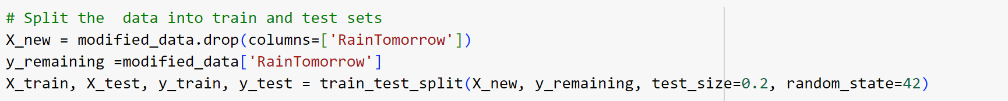

**Figure 4.1** Code snippet for Dataset splitting

Figure 4.1 shows the code snippet used to split the dataset in to training and testing data.

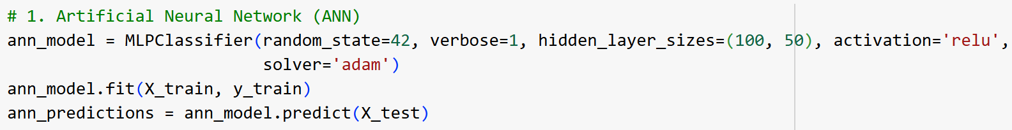

**Figure 4.2** Code snippet for ANN model training

Figure 4.2 shows the code snippet for training ANN model.

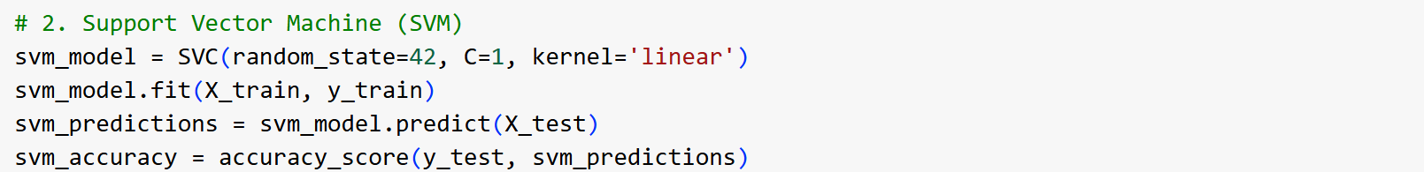

**Figure 4.3** Code snippet for SVM model training

Figure 4.3 shows the code snippet for training SVM model.

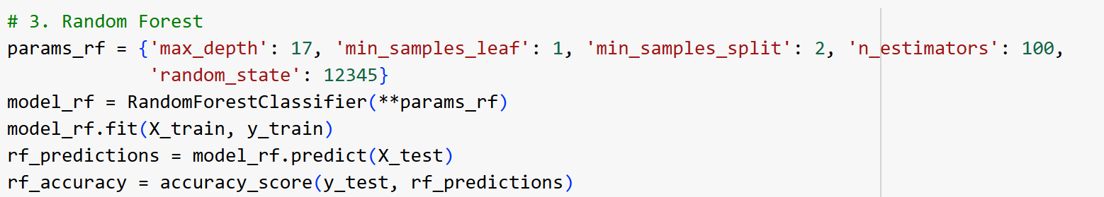

**Figure 4.4** Code snippet for RF model training

Figure 4.4 shows the code snippet for training RF model.

### Training

The training phase in the rainfall prediction project involves constructing prediction models using Artificial Neural Networks (ANN), Support Vector Machines (SVM), and Random Forest (RF) algorithms. The WeatherAUS dataset is split into training and testing sets to evaluate model performance effectively. After data preprocessing, feature matrices and labels are created for model training. Each algorithm is trained using the entire training set to learn patterns between meteorological parameters and rainfall occurrence.

* **ANN**: The ANN model is trained with multiple layers, using backpropagation to minimize the loss and improve prediction accuracy.
* **SVM**: The SVM model is trained to find the optimal hyperplane that separates rainy and non-rainy days by maximizing the margin between classes.
* **RF**: The Random Forest model is constructed by training multiple decision trees on bootstrapped samples of the training set, aggregating their predictions to enhance accuracy and reduce overfitting.

Throughout the training phase, hyperparameter tuning is performed for each algorithm to identify the optimal configuration that maximizes predictive performance.

### Testing

The testing phase evaluates the ability of the ANN, SVM, and RF models to generalize to new data. The test set is used to assess model performance on unseen data, providing insights into the accuracy, precision, recall, and F1-score for each algorithm. This evaluation helps determine each model's robustness in predicting rainfall.

* **ANN Testing**: The ANN model’s performance is evaluated based on its accuracy and error rate on the test set, assessing how well it captures non-linear relationships.
* **SVM Testing**: The SVM model’s effectiveness is measured by its precision and recall, which determine how well it can classify rainy versus non-rainy days.
* **RF Testing**: The RF model’s results are analyzed to check for overfitting, with particular attention to its ability to generalize due to its ensemble nature.

The iterative refinement process involves adjusting model parameters and retraining based on testing results, enhancing each model’s performance. This validation ensures that the models align with the project’s objectives, providing reliable and accurate rainfall predictions.

# 5. RESULTS AND DISCUSSION

# The results of the rainfall prediction models—Artificial Neural Network (ANN), Support Vector Machine (SVM), and Random Forest (RF)—demonstrate varying levels of performance in terms of accuracy, precision, recall, and F1 score.

# The ANN model achieved an accuracy of 87.61% and a training accuracy of 88.01% , indicating a strong alignment between training and testing performance. With a precision of 85.96% and recall of 89.99% , the ANN model demonstrates a balanced trade-off between correctly predicting rainfall events and minimizing false positives. The F1 score of 87.93% confirms the ANN’s reliability in handling both precision and recall, making it an effective model for rainfall prediction where a slight bias towards recall is acceptable to ensure rain events are not missed.

# The SVM model achieved an accuracy of 80.77% with a training accuracy of 81.17% , suggesting a consistent but slightly lower performance than the ANN model. The precision of 80.75% and recall of 80.97% indicate that the SVM model has a balanced prediction capability but slightly underperforms in identifying rainy days compared to the ANN and RF models. The F1 score of 80.86% shows that while the SVM model is capable, it may not be as robust as ANN and RF for this specific task, particularly in capturing complex relationships in the data.

# 

# The Random Forest model stands out with the highest accuracy of 90.13% on the test set, although it exhibits a significantly higher training accuracy of 97.82%, which could suggest a slight tendency towards overfitting.With a precision of 90.19% and recall of 90.13% , the RF model achieves an optimal balance between correctly identifying rainy days and avoiding false positives. The F1 score of 90.16% confirms RF as the most reliable model among the three, effectively handling both precision and recall requirements for rainfall prediction. The ensemble nature of Random Forest enables it to capture complex data patterns while maintaining robustness in prediction.

# Among the three models, Random Forest (RF) achieved the highest accuracy, precision, recall, and F1 score, indicating its superior predictive capability for rainfall prediction. Its ensemble approach likely contributes to capturing complex patterns in the meteorological data. However, the noticeable gap between training and testing accuracy suggests potential overfitting, warranting careful tuning or validation for real-world application.The Artificial Neural Network (ANN) also performed well, particularly in recall, indicating its ability to identify rain events with high accuracy. This makes ANN a strong candidate where identifying potential rainy days is a priority, even if it means allowing some false positives.The Support Vector Machine (SVM) model, while effective, demonstrated slightly lower performance in all metrics compared to ANN and RF. Its simpler decision boundary might be less suited to the complex nature of weather data, resulting in its relatively lower accuracy and F1 score.

# In conclusion, Random Forest appears to be the best-performing model for this rainfall prediction task, with ANN also showing strong performance and providing a viable alternative when slightly higher recall is preferred. The SVM model, though less effective in this context, still provides valuable insights and may be useful when computational efficiency is a priority.

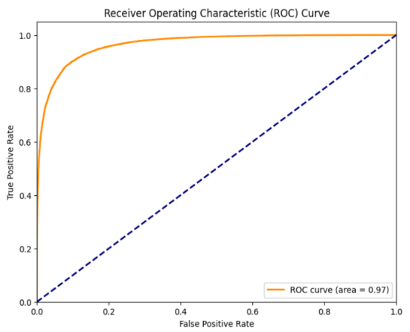 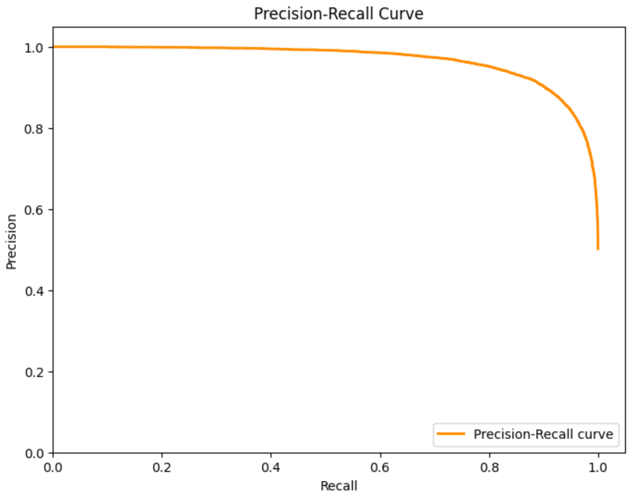

**Figure 5.1** ROC Curve  **Figure 5.2** Precision-Recall Curve

Figure 5.1 and 5.2 shows the ROC curve and Precision-Recall curve for Random Forest model .

The ROC curve displays the trade-off between the true positive rate (sensitivity) and the false positive rate (1-specificity) across different thresholds.The blue dashed line represents a random classifier, while the orange curve represents the model's performance. The closer the curve follows the left-hand border and the top border, the better the model's performance.The area under the ROC curve (AUC = 0.97) is a performance metric, where a value close to 1 indicates excellent classification capability.

This Precision-Recall Curve shows the relationship between precision (the proportion of positive identifications that were actually correct) and recall(the proportion of actual positives identified correctly).

In the case of imbalanced datasets, the precision-recall curve provides a more informative view of a model's performance.A curve close to the top right corner indicates better performance, meaning high precision and recall.

Both plots suggest that the Random Forest model performs well, with a high degree of accuracy and a good balance between precision and recall.

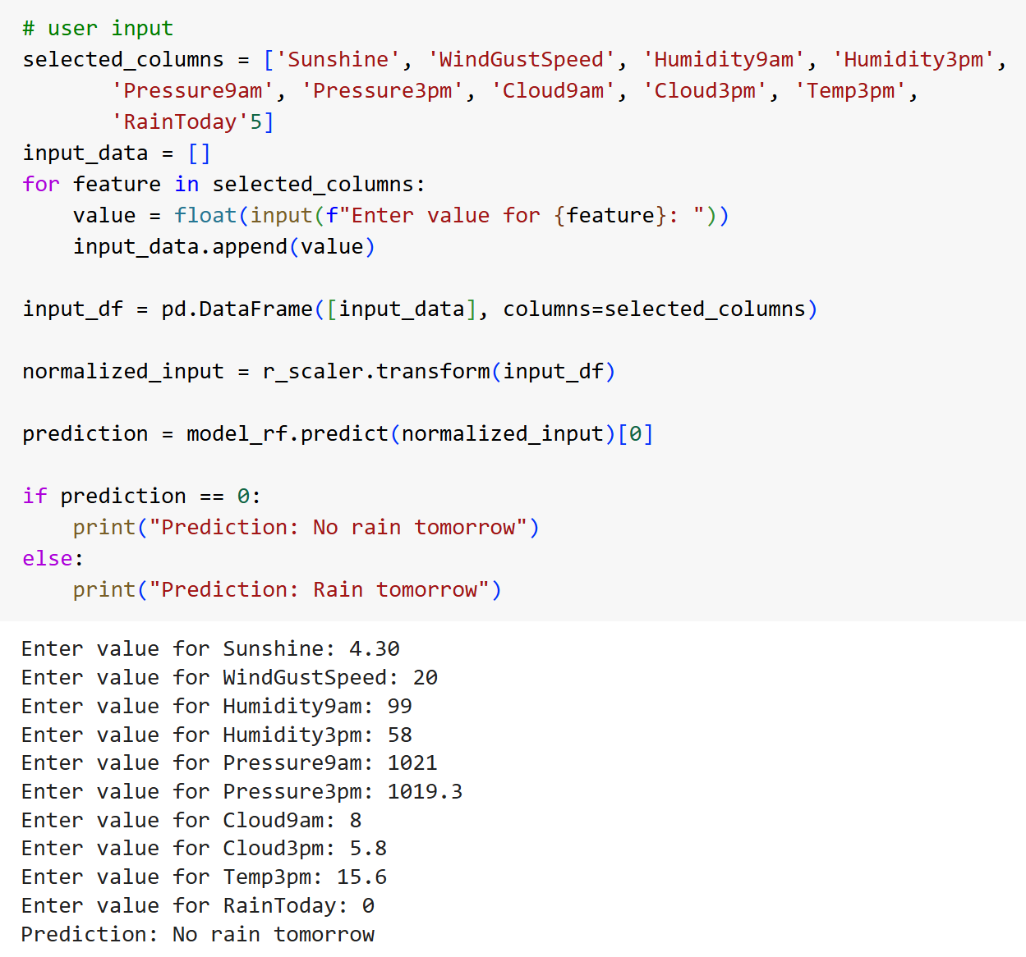

**Figure 5.3** Code snippet for rainfall prediction



**Figure 5.4** Rainfall Prediction

Figure 5.3 and 5.4 shows the code snippet for predicting whether it rains in 24 hours or not and it’s corresponding output.

# 6. MODEL DEPLOYMENT

The primary objective of model deployment in this project is to integrate the Random Forest model, developed during the training phase, into a production environment. By deploying this predictive model, the project aims to deliver an accessible solution for forecasting rainfall, catering to the needs of users such as farmers, weather analysts, and other stakeholders.

To facilitate deployment, the project utilizes Flask as the backend framework, integrating the scikit-learn library for model handling and prediction. Flask provides a lightweight and effective solution for deploying machine learning models as APIs, allowing seamless interaction between the model and the user interface.

**User Interface (UI):**

The rainfall prediction model is made accessible through a simple web interface, designed for straightforward interaction. The interface includes:

* **Input Fields**: Users can enter relevant weather data (e.g., temperature, humidity, wind speed) to receive rainfall prediction.
* **Predict Button**: Upon entering the data, users click the predict button to obtain the forecast result.
* **Output Display**: The prediction outcome (rain/no rain) is displayed on another page, allowing users to quickly interpret the forecast.

This design ensures a user-friendly experience, making the application accessible to individuals with various levels of technical expertise. The web interface is optimized for clarity, with easy navigation and clean design, supporting practical usage in real-time scenarios.

Figure 6,1 shows the home page. After clicking the button “Get Started” it will navigate to the next page, which is index.html , shown in the figure 6.2 , which allows user to input the data to get the prediction result.

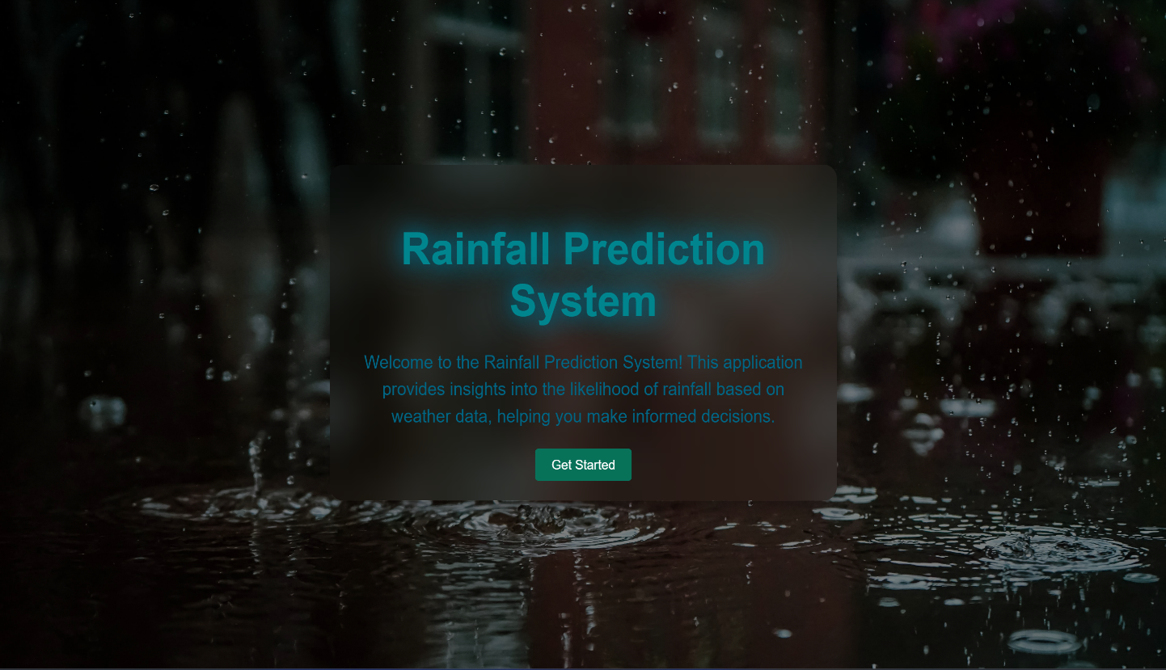

**Figure 6.1** Home Page

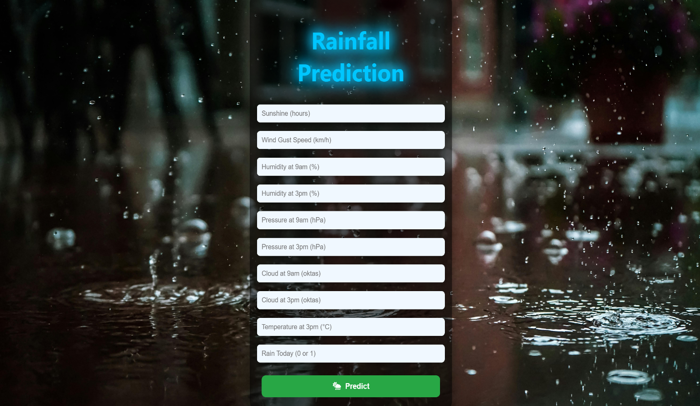

**Figure 6.2** Index Page

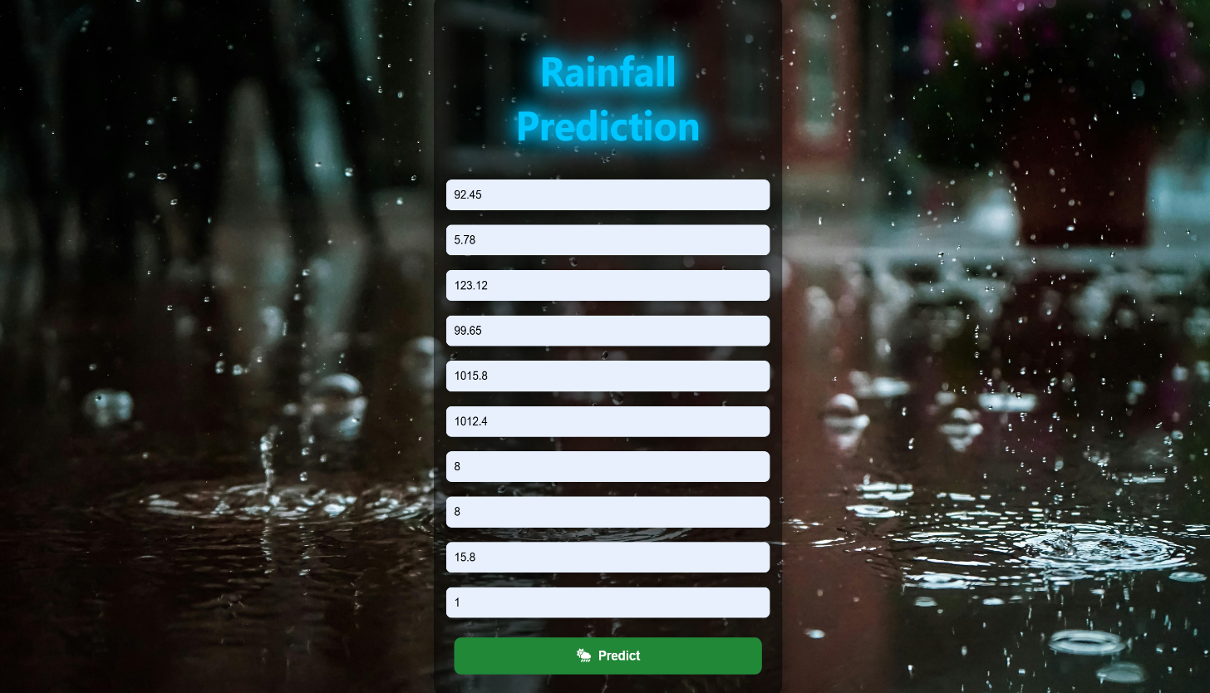

**Figure 6.3** User input

Figure 6.3 shows the user input. After clicking button “Predict” button ,it shows an alert shown in the figure 6.4.

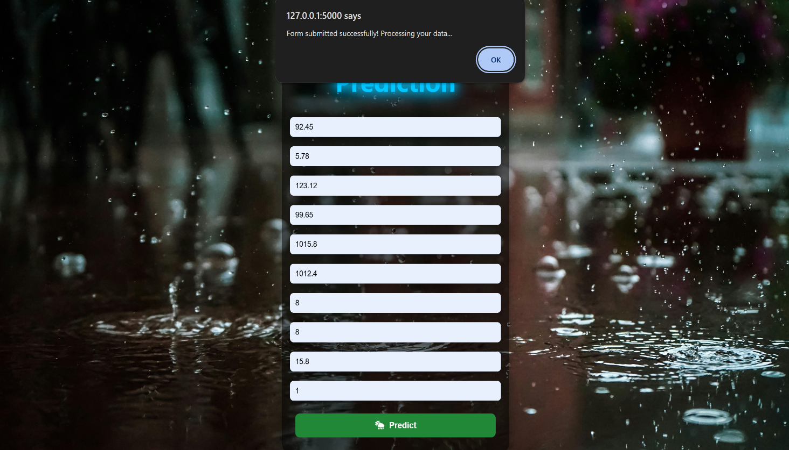

**Figure 6.4** Alert while submitting the input

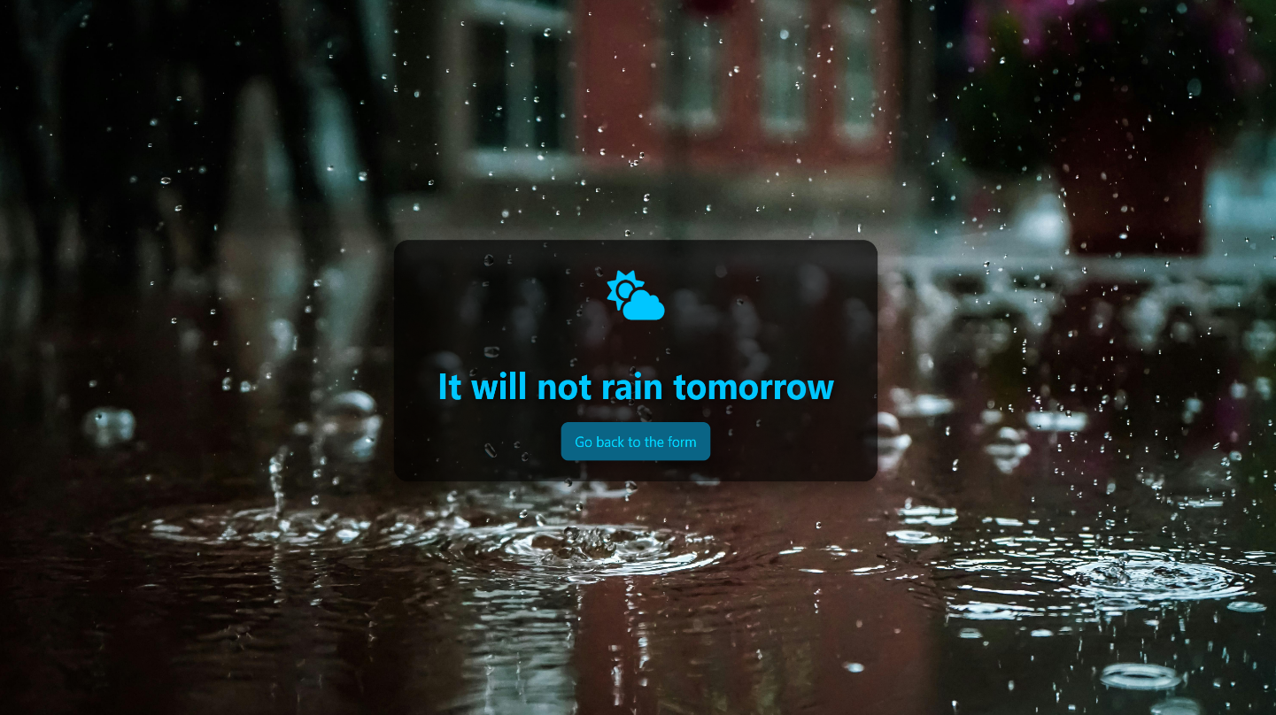

**Figure 6.5** Prediction

Figure 6.5 shows the prediction for the input data.

# 7. GIT HISTORY

Git Repository Rainfall Prediction System contains all colab files, py files, html files and three related research papers. It is maintained for systematic way of project presentation and mainly for future reference. The colab files are created separately for three sprint releases during the project.

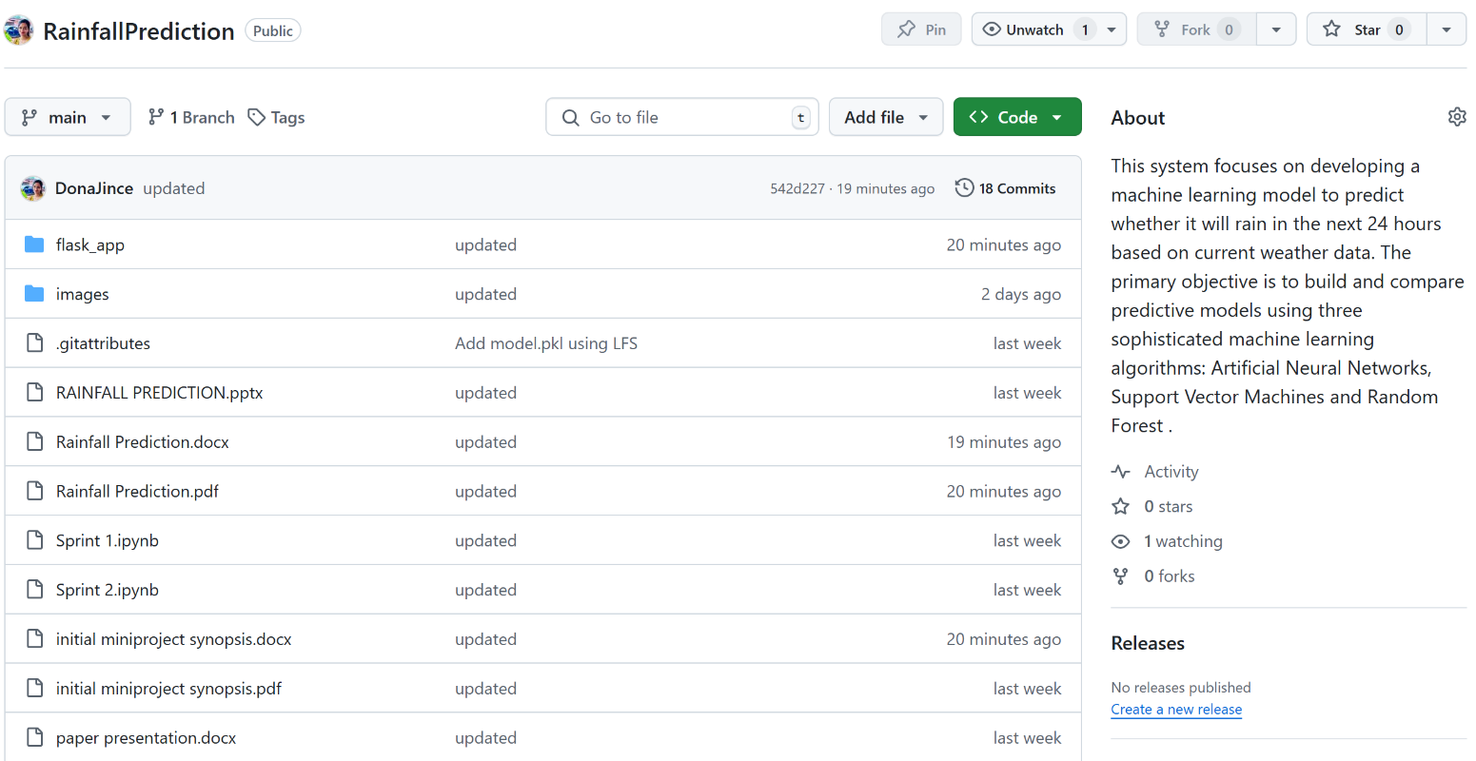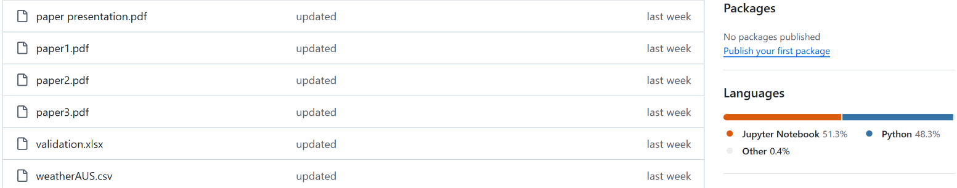

**Figure 7.1** Git History

Figure 7.1 shows the git history of Rainfall Prediction System. Figure 7.2 shows the git history of sprint 3.

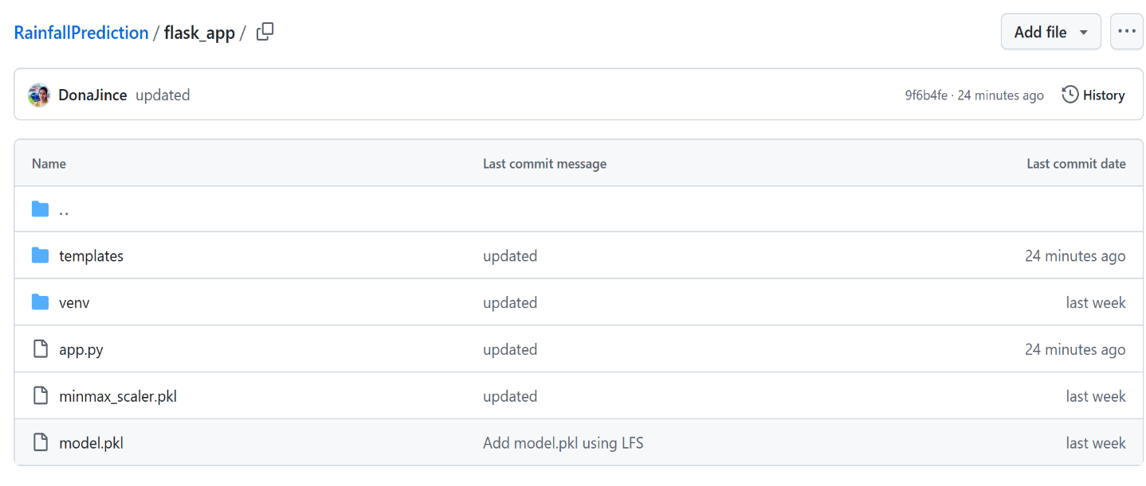

**Figure 7.2** Git History of Sprint 3

# 8. CONCLUSION

The Rainfall Prediction System project represents a significant step forward in utilizing machine learning to address complex environmental forecasting challenges. Through the development and comparative analysis of three machine learning models—Artificial Neural Networks (ANN), Support Vector Machines (SVM), and Random Forests (RF)—the project has successfully demonstrated the capability of data-driven approaches to accurately predict rainfall. Among the models tested, Random Forest emerged as the most effective, delivering the highest accuracy and robustness, which ultimately led to its selection for deployment.

The project's core accomplishment lies in transforming raw weather data into actionable insights, a task achieved through meticulous data preprocessing, feature selection, and model optimization. By employing these techniques, the Rainfall Prediction System can support timely and informed decision-making for various applications, particularly in sectors such as agriculture, water resource management, and disaster preparedness. Predicting rainfall with accuracy can greatly influence crop planning, irrigation scheduling, flood prevention, and other weather-dependent activities, underscoring the practical relevance of this project. Furthermore, the deployment of the Random Forest model into a user-friendly interface exemplifies the project’s commitment to accessibility and usability. The interface design allows users to interact seamlessly with the prediction system, making it easy for both experts and non-experts to interpret and utilize the forecast results. The successful deployment marks the transition of this project from a theoretical model to a practical tool, providing end-users with the power of machine learning at their fingertips.

This project also emphasizes the scalability and adaptability of machine learning in handling diverse datasets and complex predictive tasks. Lessons learned from this project, such as the importance of feature selection and data scaling, are instrumental for future iterations and applications. The challenges encountered, such as model tuning and deployment considerations, have provided valuable insights that will inform ongoing improvements.

In summary, the Rainfall Prediction System is more than a proof of concept; it is a practical application of machine learning that holds real-world value. By bridging the gap between predictive accuracy and user accessibility, this project has laid a solid foundation for future innovations in rainfall forecasting. As a data-driven solution, it not only meets current needs but also sets the stage for future advancements in weather prediction technologies, contributing to a more resilient and informed society.

# 9. FUTURE WORK

To further improve and expand the Rainfall Prediction System, several key areas of future work have been identified:

* **Advanced Machine Learning Models**: Future work could explore more sophisticated models, including deep learning architectures like LSTMs and CNNs, which may capture temporal patterns in weather data more effectively, potentially improving prediction accuracy.
* **Incorporation of Real-Time Data**: Integrating real-time weather data sources could enhance the model's accuracy and relevance, enabling up-to-the-minute predictions. This would be particularly beneficial in regions with rapidly changing weather conditions.
* **Dynamic Model Updating**: To maintain accuracy over time, future implementations could employ dynamic model updating, retraining periodically as new data becomes available. This would help the model adapt to evolving weather patterns caused by climate change.
* **Explainability and Transparency**: Making the model’s predictions more interpretable would increase user trust. Adding explainability tools, such as SHAP (SHapley Additive exPlanations) or LIME (Local Interpretable Model-agnostic Explanations), would allow users to understand the factors influencing each prediction.
* **Scalability and Cloud Integration**: As data volumes grow, optimizing the system for scalability will be crucial. Deploying the model on cloud platforms with distributed computing capabilities can ensure that it remains responsive and efficient, even with increased user demand.
* **User Feedback Mechanisms**: Implementing a feedback loop where users can provide feedback on the model's predictions would allow for continuous improvement. This data could be leveraged to iteratively fine-tune the model, making it more adaptive and responsive to real-world needs.
* **Regional-Specific Models**: Developing models tailored to specific regions could improve accuracy by taking into account localized weather patterns. This would be particularly useful in areas where unique climate conditions influence rainfall.
* **Integration with IoT for Precision Agriculture**: Future iterations could consider integrating with IoT devices on farms, allowing for hyper-local weather data collection. This would enable the system to deliver even more targeted and actionable predictions for agricultural purposes.

In summary, by incorporating advanced modeling techniques, real-time data, explainability, scalability optimizations, user feedback, and regional specificity, the **Rainfall Prediction System** can evolve into a more adaptive, user-centric platform. These improvements will enhance its value to users and its potential as a tool for informed decision-making in weather-sensitive fields.

# 10. APPENDIX

## 10.1 Minimum Software Requirements

To deploy and run the Rainfall Prediction System, the following minimum software requirements must be met:

* Python:

Version 3.6 or above is required to execute the project code and its dependencies.

* NumPy:

Essential for numerical operations and array manipulations in Python.

* Pandas:

Necessary for data manipulation, cleaning, and analysis.

* Scikit-learn:

The scikit-learn library is used for machine learning functionalities, including the implementation of the Artificial Neural Networks, Support Vector Machines and Random Forest algorithms.

* Matplotlib and Seaborn:

Required for data visualization and generating plots and charts.

* Pickel:

Used for serialization and deserialization of Python objects, particularly for saving and loading machine learning models.

* Flask

A lightweight web framework to serve the application and provide the user interface. Flask is required to manage HTTP requests and deliver predictions via the web interface.

## 10.2 Minimum Hardware Requirements

The Rainfall Prediction System is relatively lightweight, but it does involve some computational processes. The minimum hardware requirements to ensure smooth execution are as follows:

Processor (CPU):

A modern multi-core processor (e.g., Intel Core i5 or equivalent) is recommended to handle the computation involved in the forcating algorithms efficiently.

RAM:

A minimum of 8 GB RAM is recommended to manage the dataset and perform machine learning operations smoothly.

Storage:

Adequate storage space for storing datasets, code, and any additional resources. While the system itself doesn't require extensive storage, having sufficient space for datasets and potential model persistence is essential.

Internet Connection:

An internet connection is necessary for downloading datasets, libraries, and dependencies during the setup phase.

# 11. REFERENCES

1. Hassan MM, Rony MA, Khan MA, Hassan MM, Yasmin F, Nag A, Zarin TH, Bairagi AK, Alshathri S, El-Shafai W. Machine learning-based rainfall prediction: Unveiling insights and forecasting for improved preparedness. IEEE Access. 2023 Nov 16;11:132196-222.
2. Sarasa-Cabezuelo A. Prediction of rainfall in Australia using machine learning. Information. 2022 Mar 24;13(4):163.
3. Ghosh S, Gourisaria MK, Sahoo B, Das H. A pragmatic ensemble learning approach for rainfall prediction. Discover Internet of Things. 2023 Oct 9;3(1):13.https://doi.org/10.1007/s43926-023-00044-3
4. Kaggle, WeatherAUSdataset:

https://www.kaggle.com/datasets/trisha2094/weatheraus

1. https://www.kaggle.com/code/midouazerty/rainfall-prediction-with-6-machine-learn-algo-98#Plotting-Decision-Region-for-all-Models